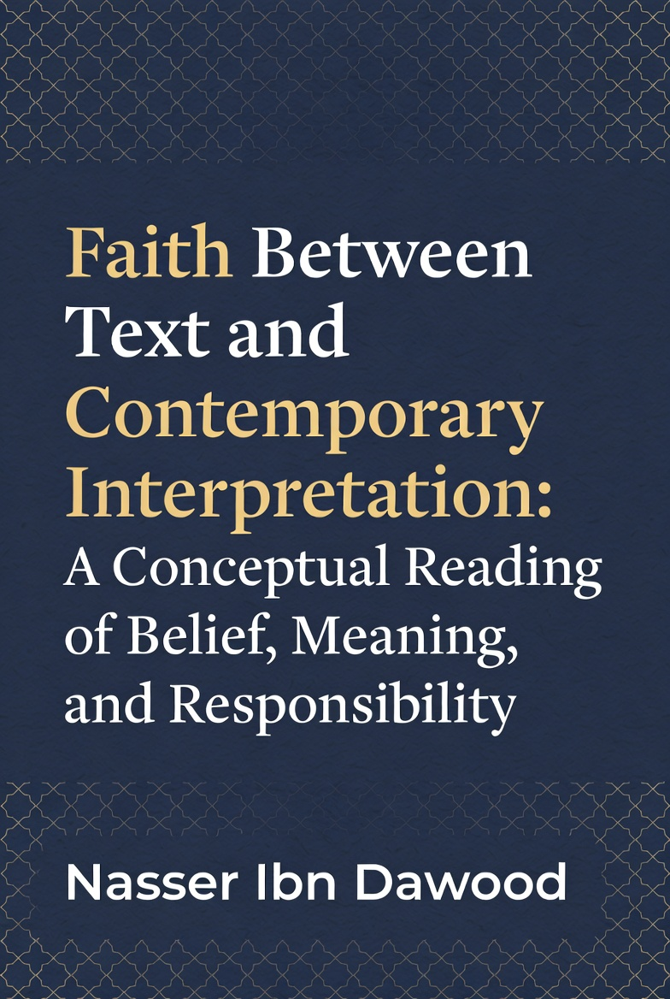

Faith Between Text and Contemporary Interpretation: A Conceptual Reading of Belief, Meaning, and Responsibility

By Nasser Ibn Dawood
For readers interested in exploring the full depth and nuances of the original Arabic edition, which provides expanded discussions and references, the complete book is freely available in my digital library at https://nasserhabitat.github.io/nasser-books/. You may download the Arabic version and utilize Google Translate for a quick, real-time translation to English or any preferred language. This English edition is a condensed conceptual adaptation, designed for accessibility and intellectual engagement, but the source material offers additional layers for those wishing to delve deeper.
https://nasserhabitat.github.io/nasser-books/

https://github.com/nasserhabitat/nasser-books

**Preface to the Western Reader**

In an era where "faith" is often invoked as a shield for identity, a justification for conflict, or a vague spiritual comfort, it becomes essential to pause and ask: What does faith truly entail? This book is not a defense of dogma, nor an attempt to convert or confront. Rather, it is an intellectual exploration of the concept of faith (īmān) as presented in the Qur'anic text—a linguistic and conceptual system that demands precision rather than assumption.

For the Western reader, accustomed to discussions of faith through lenses like Kierkegaard's "leap" or Nietzsche's critique of religion, this reading offers a fresh perspective. Here, faith is approached not as an emotional or existential state, but as a structured concept rooted in language, responsibility, and action. The Qur'an is treated as a self-contained textual framework, where words are chosen with intentionality, distinguishing between belief, trust, security, and ethical commitment.

This condensed edition distills the original Arabic work into a conceptual essay, avoiding polemics and focusing on clarity. It invites you to engage with faith as a problem of meaning—one that transcends cultural boundaries and challenges us to rethink how belief shapes human responsibility. Whether you agree or differ, the goal is deeper awareness, not adherence.

Nasser Ibn Dawood
January 30, 2026

**Chapter 1: What Do We Mean by "Faith"?**

Faith is one of those terms that seems self-evident until scrutinized. In common parlance, it might mean unquestioning belief, emotional certainty, or affiliation with a group. But what if faith is none of these—or rather, more than these? In this reading, faith emerges as a conscious commitment, a stance toward the unseen that integrates intellect, choice, and accountability.

Consider faith not as passive acceptance but as an active orientation. It is not merely believing in something despite evidence (or lack thereof); it is a reasoned conviction about realities beyond sensory perception. This conviction demands verification through logic and observation, leading to a certainty that motivates ethical living. Faith, in this sense, is not blind; it is the product of deliberate reasoning.

Yet, faith is often conflated with identity. In contemporary discourse, it becomes a marker of "us versus them," justifying exclusion or violence. This misstep arises from ignoring the term's conceptual depth. Faith is personal yet communal, internal yet manifest— a bridge between the heart's conviction and the world's demands.

At its core, faith is responsibility. It is not an escape from doubt but an embrace of it, resolved through inquiry. Without this, faith risks becoming superstition or ideology, detached from meaning.

**Chapter 2: The Qur'anic Use of Language: Why Words Matter**

Language is not neutral; it shapes thought. In the Qur'anic framework, terms are precise, with roots and derivations carrying distinct meanings. Misreading them leads to distorted interpretations. Take "īmān" (faith), derived from the root "a-m-n," which also yields "amn" (security) and "amīn" (trustworthy). These are related but not identical.

"Īmān" refers to a conviction in the unseen—God, angels, scriptures, prophets, the afterlife, and divine decree—achieved through rational deduction. It is transitive with prepositions like "bi-" (in/by), as in "āmena bi-llāh" (believed in God), emphasizing intellectual assent.

Contrast this with "amn," which denotes safety or peace from fear. For instance, providing security to others is "amn," not "īmān." Confusing the two reduces faith to mere behavior, ignoring its cognitive foundation. The Qur'an pairs opposites carefully: the antithesis of faith is disbelief (kufr), hypocrisy (nifāq), or association (shirk)—all intellectual or attitudinal states—not fear or insecurity.

Why does this matter? Contemporary interpretations often blend these, turning faith into social ethics alone. But the text insists on distinction: faith is the root, ethics the fruit. Mistranslations erode this, leading to faith as "submission" without inquiry, or as "peace" without conviction.

In a Western context, this echoes philosophical debates on semantics—think Wittgenstein's language games—where words define reality. Here, the Qur'anic language is a system: self-referential, where one verse illuminates another, demanding linguistic rigor for conceptual accuracy.

**Chapter 3: Faith and Action: Separation Without Disconnection**

Faith without action is hollow, but action without faith is mechanical. The key is separation without disconnection: faith as the inner conviction, action as its necessary expression.

In this view, faith is not measured by deeds but validated by them. Good actions—justice, compassion, integrity—emerge from true faith, like fruit from a healthy tree. Yet, deeds alone do not constitute faith; a hypocrite may act ethically while lacking conviction.

This avoids two extremes: reducing faith to ritual (legalism) or to emotion (mysticism). Instead, faith heightens responsibility: the believer is accountable not just for actions but for intentions rooted in conviction.

Drawing a conceptual parallel (without direct comparison), this resonates with Kantian ethics, where duty stems from rational will, not mere habit. Faith amplifies this: it is a commitment to ethical laws derived from reasoned belief in a transcendent order.

In practice, this means faith inspires social harmony—providing "amn" (security) to others—but does not equate to it. A believer in peril may still hold faith, as conviction transcends circumstance. Action disconnects from faith only when it contradicts conviction, leading to hypocrisy.

Ultimately, faith and action are intertwined: the former ignites the latter, creating a responsible life.

**Chapter 4: Contemporary Readings: Where Confusion Begins**

Modern interpretations of faith often stray from textual precision, influenced by cultural, political, or philosophical pressures. Three common pitfalls emerge.

First, faith reduced to morality: Here, belief becomes synonymous with ethical behavior, like "granting security" to society. While appealing in a secular age, this empties faith of its cognitive dimension, turning it into humanism without transcendence. The text counters this: faith is belief in the unseen, from which ethics flow.

Second, faith weaponized politically: In some discourses, faith justifies division or coercion, conflating conviction with group loyalty. This ignores the Qur'anic emphasis on personal responsibility and rational inquiry, where faith unites through shared humanity, not divides.

Third, faith diluted into spirituality: Vague notions of "inner peace" or "universal energy" strip faith of structure, making it subjective and unverifiable. The original concept demands intellectual engagement, not emotional vagueness.

These confusions arise from overlooking linguistic distinctions and imposing external agendas. In a global context, they mirror Western debates—faith as social control (Marx) or personal therapy (New Age)—but the Qur'anic reading offers balance: faith as meaningful commitment, resistant to reduction.

**Chapter 5: Faith as Responsibility, Not Immunity**

Faith does not grant immunity from error or accountability; it heightens them. A believer is not superior by default but responsible for aligning conviction with action.

This challenges notions of faith as a "get-out-of-jail-free" card. Wrongdoing nullifies actions' merit if rooted in disbelief or arrogance, but true faith demands self-correction. The believer must confront doubts, refine understanding, and embody ethics.

In this framework, faith increases vulnerability: it exposes one to divine scrutiny, where intentions matter as much as outcomes. No one is "saved" by affiliation alone; responsibility is universal.

For Western readers, this echoes existentialism—Sartre's "bad faith" as self-deception— but with a transcendent anchor. Faith is authentic living, where belief imposes ethical demands, fostering growth rather than complacency.

**Chapter 6: What Remains Open for Discussion?**

Interpretation has limits: the text sets boundaries, but human understanding evolves. Faith accommodates pluralism—different paths to truth—without relativism. It invites dialogue, not imposition.

Open questions include: How does faith adapt to AI and modern ethics? Can it transcend identity politics? These remain fertile for exploration.

**Final Reflection: Belief Without Awareness Is Not Faith**

Faith thrives on awareness. Without questioning and refining, it stagnates. This reading invites you to engage: not as doctrine, but as a call to meaningful existence.

**Back Cover**

What does faith really mean? Is it inner certainty, ethical action, or something deeper? This conceptual essay explores faith through the Qur'anic lens, distinguishing belief from security and conviction from identity. A thoughtful guide for seekers of meaning.

**Author Bio**

Nasser Ibn Dawood is an engineer and independent researcher in Qur'anic linguistics, blending analytical rigor with conceptual inquiry. His works focus on liberating sacred texts from institutional constraints, promoting open, reasoned engagement.

